INSIDE/OUT
ART AND MENTAL HEALTH

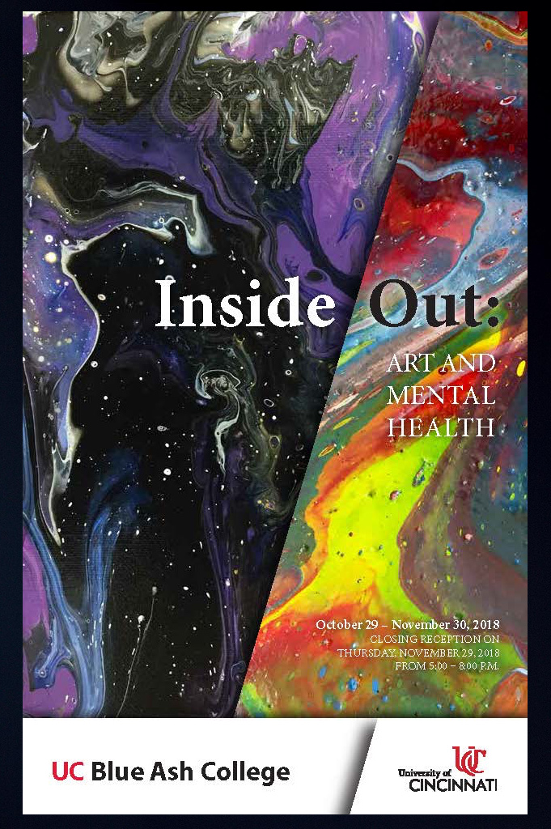

A COLLECTION OF POETRY
RELATED TO THE EXHIBITION

CURATED AND EDITED BY
H. MICHAEL SANDERS

Copyright © 2018 University of Cincinnati
All rights revert to the authors

A project of the
University of Cincinnati Blue Ash College Art Gallery
Blue Ash, Ohio
In conjunction with the exhibition Inside/Out Art and Mental Health
October 29 – November 30, 2018
H. Michael Sanders and John Wolfer, Curators

Against All Odds
By Linda Baden

Is the hill so steep
That I can't climb over it?
Every day I begin with vigor
But soon I lose my zest.

I know if I can
Overcome this obstacle
I will outlive my dreams
Or wlll I?

The choice is mine
And yet my mind
Is riddled
With skepticism and doubt.

I must obliterate all negativity
So I can stand at
The top of this hill
And proclaim success.

If I have to crawl
So be it
My hands I'll use as a
Vise grip
And I'll thrust my legs forward
To break up the dirt clods.

I must let go
And not succumb
To depression or anger
For It will make ascending this hill
That much harder.

So once I overcome
That slippery slope
I will find
That anything is possible .

August 27, 2018
On Cloudy Days
By Linda Baden

On cloudy days
It all seems sad
And I wonder when the
Clouds will depart
For that rolling ball of fire
That heats the earth.
It doesn't take some magic trick
For the sun to appear
Or does it?

All of my days seem like
An existence
And in my mind I travel to
Parts unknown,
Do I think I live an existence?
Or is it that I have labeled
My life this way?
For to see the beautiful majesty
Of the world
Would take my breath away.

How can I take a drab existence?
And create it like someone who
Sings a sweet melody?
The answer must lie
Up above, or have I not
Looked deeply within my soul?

I pray that on cloudy days
May I reflect on a self
That can be more
Than what was expected.
For to be happy cannot be forced
But must be opened gently
Like the petals of a rose.

My Sweet Desperation and Anxiety
By Justin A. Chu

Part 1:
Life is Nothing Without Music

Life is nothing without music
Music is my world to calm my mind
Music is my world spinning around
It pulls me from the depths of hell
It helps me for the now and the past
It helps me leave my feelings behind to live with myself
Music helps me to calm and relax without worries
I dream of music the lyrics while I sleep to help sooth dreams
It saves my soul from more hurt keeps it soothed
I don’t want my life to be held on the back burner
All my past does is rule my mind to save it would be the true sound of music
So I let the music take control so I can forget my mind and raise my soul rise to relaxation
I’ll always be broken without music to fuel my fight
Music is my life and my demons the choir.

My Sweet Desperation and Anxiety
By Justin A. Chu

Part 2:
A Freak Like Me

I need insanity, I need a freak that can take my insanity. One who won't just die for me, but live for me. Dying is just too easy, so baby ride and die with me. I can't help I'm fucked up So I need a freak who will let me tie her up and play with her, to enjoy her. I need an insane woman to love and cherish in my own way. I know I'm an insane freak. I need a freak who won't let me down, to know my secrets, who won't use them against me. A chick that can rock my world to sanity. To keep me wanting more. I want someone who can be intertwined with me. To bleed with me. Who will fall into danger. Who got me double thinking to turn around and jump straight down into the acid. To kiss her. To keep her. I need a freak that I know there won't be no one else. Someone I can forgive. A freak I can play with. A freak that can understand my mind, my ways. I need me a fucked up relationship like the Joker and Harley Quinn. So give me a freak so I can stop breathing and start living off insanity. Love forever and always. Let's play it down into our skin, our blood, our lip s. So imperfect that it's perfect. So forgive me. I'm insanely imperfect, while you're the insanely perfect piece.

My Sweet Desperation and Anxiety
By Justin A. Chu

Part 3:
Life Spiraling Away

My life is flying, spiraling away, my mind is going insane going astray. Wish I could control my thoughts sanity seems lost, my mind is screaming I'm tired of seeing the movies of the past, I'm tired of seeing the blank screen of present day turn to ash. I wish I could shut it up, tune it out, I'm tired of with every smile outside inside I shout. Crying, I can't shed another tear, but I can Shed my blood to pleas the voices in my head to quit the fear. I can take the pain and feel alive, feel the pain push back the memories deeper inside. I'm so sick reliving them every day, I just want to die since no one can help to take them away. I can't take this closing feeling I feel so trapped, so chained down I can't breathe, I can't move, in my past I drowned. I beg for my mind to end my life, so tired of this fight, but it never does it throws a little sanity to keep the end of death’s hand at bay. I always wanted to leave this life, I'm so sick of my mind, my strife, it's driving me crazy, I can't take the feeling of disrepair I don't want to be down any more it's just not fair. I want to break away from it because I know I will always hurt everyone in my life, I will feel the blade and they will feel the knife. My mind is twisted like a spiral staircase never ending always thinking never stopping, replaying the past,replaying the pain the movie always the same.

My Sweet Desperation and Anxiety
By Justin A. Chu

Part 4:
Be You

Don't be afraid of being you, no matter what that is be it old or new, if you like the same sex, if you feel that you are another sex, if you are weird be weird and have no fear just be your best. If it means you want to me, the opposite of me just be free. Look in the mirror and love what you see. Don't be afraid to be you, only you can unlock yourself, free yourself and remove yourself from the shelve. The sooner you find the key and unlock yourself the quicker it'll be to be free, it took forever for me to be free but now I find that I can fly no limit open sky. I was scared but I was able to come out and be me, it's not easy to be free but it's what makes us who we are, wonderful and amazing. I don't want to die without giving you the advice I wish someone would have given me a long time ago, let go of your fear and self-doubt fly among the stars and clouds let yourself out. Only you can be yourself, live your life to the fullest like no one else, love yourself to the fullest you rule this. Don't let the bad vibes bring you down don't let no one make you feel unhappy or like a clown, live your life for you not for them. They don't live your story so go and capture your glory, so be free.

My Sweet Desperation and Anxiety
By Justin A. Chu

Part 5:
Puddle of Blood

I just want to sit in this puddle of blood feeling so high, feeling its charms able to forget my past memories as they flow down my arms. I feel so Alice with each slice of the blade taking the pain away taking me off to wonderland for another day. Physical pain ant a thing, but the emotional pain destroys me from the inside voices that cry out in my head tell me things I don't Want to hear show me things I don't want to see I can escape I'll never be free. All I see is dark what can I do to break these chains lose this part, I'm trying to keep my head down I'm I try not to look around. Tired of disappointing everyone this weight is a ton, all I do is crash every one's world I am like the oyster with no pearl, there will always be something I say or do that brings them down knowing that soon no one will come around. It makes a cut inside my brain, rips at my heart, what can I say I'm just a little twisted so how I want to but how can I change with so much pain.

Silent Tears
By Aly Lily Dempsey

In the darkness
my tears flow and flow.
They roll down my cheeks,
small, smooth beads on a journey.

It seems it takes no effort
for the tears
to flow and flow,
roll and roll,
down my cheeks.

They come with no sound.
They are silent.
I am silent.
We are silent.

My hands suddenly feel wet
as we look down to see
drops from our tears speckling
all over our hands and arms.

As our body is
crunched and curled,
we are trying with everything
...everything...
to hang on.

Inside of us
the effort to keep on...
to hang on,
to have hope,
to survive;

this effort is more
than any words could ever describe

The tears are silent.
They seem to flow and roll
easily and smoothly.

Inside us though,
our cells are tearing violently.
Our insides are bleeding.

The sound in our ears:
heavy, thick, static confusion.
We are trapped, frozen,
without any clear meaning.

But the feeling...the feeling...
is complete, strong, bold.
There is no doubt
what this feeling is.

We are being sucked
into the haunting depths
of a black hole.

It is silent,
But horribly powerful.

Around and around
we are swirling.
The force of the black hole
relentless…
Now, I have to be relentless too!

How we ever found
the strength
to get just far enough away
from the black hole
taking us forever…
(will be something I may never
quite understand).

The soul must know though;
somehow, someway,
that it is meant to keep on.

Through the pain;
physical and mental.
Through the confusion,
the fog, the frozenness…

Somehow, someway
we keep on.

The black hole never travels
far from us though.

It seems to be obsessed
with wanting to end us.

My soul though
must be obsessed too.
Obsessed with wanting to do its best;
with what it is,
with what it has to struggle with
and to having a purpose
and a meaning
in this world.

The force of the black hole
is unlike any other force
we have ever experienced.

When it comes close to us
in the vast universe,
we know what it wants.

And sometimes we think
that with this pain;
physical and mental,
there is no way to keep on.

Sometimes we think
the body will not be able
to climb far enough away
from the black hole's terrifying force.

The black hole is powerful.
The black hole is relentless.
The black hole wants to take me.
The black hole wants to take us.
To nothingness...

But my soul, my spirit
Is also powerful.

My soul, my spirit
Is also relentless.

Each and every day…
hour,
minute,
second,

the soul, the spirit
tries and tries and tries…

We try with all our might
to travel farther and farther away
from the black hole,
and closer and closer to the
Sunlight.

Sometimes we see
a little ray of that sunlight.

And for that truly
Blessed moment,
that little ray of sunlight
is more powerful
than the black hole.

The sunlight ray;
even if it is far away and faint,
must be there for a reason.

It is to remind me,
remind us,
we do have meaning.
We do have purpose.

That little faint,
but magnificent
ray of sunshine
touches our body,
touches our soul.

It comforts us.

It encourages us.
It is there to let us know,
to remind us,
that our soul,
our spirit,
is indeed
stronger than any black hole.

And by noticing and experiencing
that very first little
ray of sunshine,
we are sent on a path,
a journey...

Then each day…
we are blessed
with another little ray.

Sometimes that ray
is very far away.
Sometimes that ray
is very faint.

But, it is still a ray.
And any ray;
no matter how small,
how far,
how faint,
is more powerful
than any black hole.

And so, our journey that begins
with these silent tears,
with the cells inside us
tearing violently.

This journey;
brings us eventually,
eventually to the sunlight.

If we can have the courage,
the faith,
to keep on,
to climb out of,
and away from
every black hole
which travels close to our being;
the sunlight will eventually come.

Yet the journey is never over.
The beginning
with the silent tears,
the tearing of cells,
the pain; physical and mental,
it will come again.

And we will start over
at the beginning;
fighting to reach
and to see
the sunlight.

Each time we are sent back
to the beginning
of the journey.

Each time we are
thrust into the
storm surrounding
the black hole.

But –
we somehow, someway
are able to remember
again and again…
if we hang on;
somehow, someway
hang on
with everything we have,

the sunlight,
that little, beautiful,
magnificent ray
will come.

And we will be renewed.
We will be bathed with warmth,
with hope,
and reminded
the journey
is worth it.

We are worth it!

[2015]

The Battle
By Shelly Kinder

Here I am...again
Exhausted, wondering where I fit in
My head is full
Unwanted thoughts
Shame, guilt, failure
When will they stop?

No one is listening
No one cares
My heart knows that's a lie
My mind is unaware

I'm tired voices, let me be!
Frustrated, sad, angry, lonely, lost, hopeless
Then I realize...that voice is ME!

I'm awake, I'm happy
Ready to f ace this new day
Moments later...
That excitement fades away

A constant battle going on in my head
Good thoughts fight to stay in
Bad thoughts always seem to win

Tomorrow is a new day, I'll try again
For now I'll dream of the confident, carefree, fun me
She lies beneath the weight of this concrete
In my dreams she breaks free
I think I'll ask her to wake with me

Thinking of Ways to Not Love Myself
By Sacoiya Pruitt

Thinking of ways to not love myself. Am i not pretty enough? Am i not good enough? What am i doing wrong? Anxiety causes me to ask so many irrational questions and tear myself apart until there is no more left. Thinking of ways to not love myself when no one loves me anyways. I am a black sheep to the world, the walking plague. Am i smart enough? Do i cry too much? Is loving someone so hard wrong? Why do I feed my mental instability with insanity knowing i'm not all the way here. Do i love myself? Am i able to stare in the mirror for more 30 seconds without screaming, “you fat bitch.” I don't own any mirrors, i'm afraid. I'm afraid to see who i really am. I'm afraid to see those tired eyes from the tears ive cried. I'm afraid to see my demons in my reflection standing behind me caressing my shoulders. I'm afraid to see my bleeding heart still beating in the palm of hand. In reality i sit balled up, crying, hating the mirror and images it creates. Thinking of ways to not love myself so i can ignore it from someone else. Be able to deny the fact someone took all my shit wrapped it in one and said wow I still love her. I can't control who i am, that the world has fucked me up so many times. Yet i still love like there's still a soul, like my heart is whole, like hurt never existed, like sadness isn't breathing down my neck. I push it all away and try not to burden the one i actually allowed to have my heart. Yet i'm still thinking of ways to not love myself because when they say they do they don't, and pity takes over what used to be genuine. Daily affirmations repeated over and over and over UNTIL boom, one fucking day i actually believe that shit. And i never fucking will. I tell my voices to remain quiet but they have a mind of their own I tell you. They don't like anyone and everyone is the devil. Thinking of ways to not love myself. Like i ever loved me in the first place. I hear so many things you're so beautiful, you have such a pretty smile, you're an amazing person. Then why is it so hard to be good to me. They see the positives but will still leave. Look you in your wounded eye and exclaim how they're sooo different. NO one stays. Friends are scarce, happiness is a myth, and we're all riding a bike that only goes in circles. Thinking of ways to not love myself after being dragged through the mud daily, after being broke, abused, homeless, raped by the same one that said “i love you.” Hurt constantly day in and out till this very day. After it all i thought of ways to not love myself, to not want to breathe anymore. After it all i lie down and gave myself to my demons, after it all i was no more, after it all i was, after it all i checked out, after it all when i said i couldn't go on. I didn’t. Thinking of ways to not love myself would have been easy but finding love within me is so much more. I can hate the reflection, i can not believe the daily affirmations. Yet i also know i have a gift, and i am the gift. Thinking of ways to love myself so i wont misconstrue it with the bad intentions of someone else.
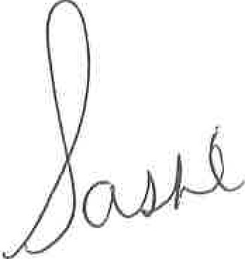

[October 3, 2017]

Womanhood
By Sacoiya Pruitt

I am just a shell with a soul inside. My heart doesn't exist, my lungs have withered and died.
There's a rose rooted at my womanhood, and the bud is in my mind. Thorns cascade around my stem giving me painful pleasure. I am nothing but someone with the intentions of accomplishing something. My roots are grounded firmly as they entangle themselves, as they grow and become stronger, as they provide the necessary nutrients to itself and visitors. My roots have quenched the thirst of many lives allowing its juices to seep through my soul and replenish my being, the bud inside my mind cradles my thoughts and holds its speaking with such tenacity, it relinquishes my liquids allowing them to flow down my stem glistening my thorns and allowing them to sharpen themselves, to inflict the pain, leaving me feeling erotic, feeling like somebody done got ahold of my roots again. Juices flowing

I am just a fucking shell with soul that's gold, a soul that holds a soul with a mind that’s old. My bud has blossomed into the potential it has to be, wants to be, needs to be, and will be, because i am that vibrant fucking flower, i am the that rose that buds and blooms, that shrivels then blossoms, my roots are planted at my womanhood where i've allowed them to come and go, where my seeds are to be planted, where my strength is firm, where my power is given, where i own control. My roots do not require any reciprocated effort because i am I, and she is we, and we are woman with stem pricking our fucking soul, stabbing at our fucking heart, crushing our very being, but yet our buds inside our mind continue to fucking bloom despite being momentarily being neglected by lack of life’s water, despite being guarded, despite just fucking being

My roots have been standing as long as i've stood, as long as i've been here, as long as i knew i could, and i am I. I FUCKING am because i say i am, because my bud doesn't bloom the ignorance of forced belittlement, my bud doesn't bloom from one's fear in thyself, thus causing inflicted terror on another, my rose doesn't bloom from drowning pessimism, my rose waters itself, my thorns they prick my soul for all eternity, they bleed the plagued non-nutrients away, they kill any threat of harm of my sanity and peace of mind, my womanhood is the strength i carry for lifelove and all kinds of pleasure, my rose is love. i have grown within my mind for ME, i am the rose that grew from the concrete, i am the forgotten seed. i allowed my bud to not bloom, i became that blossomed flower, I found the love within myself. I water my mind and let my aura shine.

I AM just a fucking shell with soul that’s gold. I am gold. My roots are grounded where my womanhood lies. My thorns are bleeding out all the indecencies. My bud blossoms only when selflove has reached is ultimate, and i am that high.. Speak universe!

I am just a fucking shell with a soul inside. My heart doesn't exist, my lungs have withered and died. My roots are grounded firmly in my womanhood but the beauty is in my mind. DO you have the time? Because i'd like to tell you who am i
Papa
By Allison Williams

I am from
A morning whistle, one earlier than the roosters,
the burning smell of fried green tomatoes
With sleeping buds lured to a breakfast
eaten with clanking forks and vacant pondering­
Not much more than any other meal.

I am from
Knotting ties before Sunday School
Warm squeezes after church
with quiet lunches
and long Sunday naps.

I am from
Car rides with Wagner,
homework with Debussy,
and bedtime with Strauss
With most words falling on Beethoven's deaf ears.

I am from
Practices times after dinner
Squeezing out remnants of Mozart before Jeopardy­
One day his Ph.D. will win us thousands.

I am from
Silence, beauty, compassion
Blood from his blood
Note from his note
Learning from his song.
A quiet melody I have always wanted to play­
If I phrase my song in the form of a question
Maybe one day I'll be heard as well.

