DSLR CAMERA GUIDE
Electronic Media Communications University of Cincinnati Blue Ash College

Common “point-and-shoot” cameras with fixed lenses (lenses that may not be removed and changed for other lenses) are not acceptable for course use, as they do not typically offer manual control of basic camera functions or adequate range of aperture control. This lack prevents users of such cameras from completing required course assignments.

While you may choose to use a digital camera not on the list, please make sure any DSLR camera selected has manual control of aperture, shutter speed and focus. In addition, the instructors cannot possibly be familiar with the wide range of cameras that may potentially be selected, and therefore may be unable to help you with the camera controls and menus if you do not also have the instruction manual for the camera.

Cameras – all cameras need to have manual exposure and focus controls Almost any DSLR made in the past 3 years will suffice.

Suitable Examples of DSLRs:
Canon DSLR – Rebel T3i, T4i, T5i, T6i, and T7i
Nikon DSLR – D3200, D3400, D5200, D5600 & pro DSLR
Olympus DSLR – E-5
Pentax DSLR – K-5, K-30, K-50
Sony DSLR – SLT –A35, A37, A57, A58, A68

Why a digital SLR?
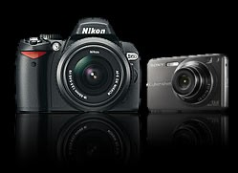
So you've decided to invest in a new digital camera and have made your mind up that you want to step up to a digital SLR, but the huge range of models on offer and endless flow of technical jargon have left you more confused than when you started? Fear not, this page will take the pain out of choosing the perfect digital SLR for you, whether you're a seasoned shooter or a total novice.

Before we get down to business it's worth stopping for a moment to ask the question:
why would anyone want a digital SLR when compact digital cameras are so much smaller, lighter and more affordable? The
answer can be summed up in two words: versatility and image quality.

The versatility isn't just the fact you can change lenses and add a wide range of accessories - from basics such as flashguns and remote controls to the more specialized equipment that allow SLRs to capture anything from the tiniest bug to the most distant stars. It's also about the creative versatility offered by the more advanced controls and higher quality components.

And this leads on to the second factor; image quality. In broad daylight the quality difference between a good compact and a digital SLR is minimal; both will produce sharp, colorful results with little effort. But when you start to push the boundaries a bit more; shooting in low light, attempting to capture fast moving sports action or wildlife, or when you want to experiment with shallow depth of field (to add a soft

background to a portrait for example), the advantage of a digital SLR's larger sensor and higher sensitivity start to make a big difference. A digital SLR can't beat a compact camera for 'pop it in the purse or pocket' convenience but for serious photography the DSLR wins hands down. With prices lower than ever it's not that surprising to discover that many people own one of each.

What is an SLR?

The basic physical design of the SLR has remained essentially unchanged for over half a century. The name itself, 'Single Lens Reflex', refers to the hinged mirror that bounces the light passing through the lens up to the viewfinder for framing then flips out of the way when you press the shutter to allow the light to hit the sensor (or film).
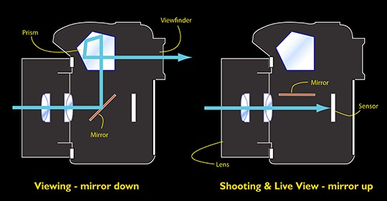
As the (simplified) diagram above shows, the mirror inside an SLR reflects the image formed by the lens up to the optical viewfinder (via a focusing screen and prism). When the picture is taken the mirror flips out of the way to allow the light to fall directly onto the sensor (or film), which sits behind a mechanical shutter. The mirror is also flipped up for live view operation (where the sensor is used to provide a live video feed directly to the screen on the back).

What do you need?
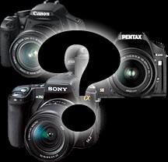
With so many digital SLRs on the market at so many different price points it's a good idea to narrow down your options by thinking about what 's important to you, and what you want to do with the camera. Do you want the same kind of 'point and shoot' simplicity as you get with a compact camera or are you the type of photographer who likes to roll up his or her sleeves and take control of every function? Many entry-level DSLRs offer a range of 'point and shoot' subject / scene modes, whereas more 'professional' models don't (though all have a basic 'auto' program mode). Do you shoot a lot of sport or wildlife? If so you'll need a fast camera with a high frame rate, and will probably want one of the smaller sensor formats.
If you shoot in very low light you'll be looking for a camera with the best possible high ISO performance and possibly in-body image stabilization, if you do a lot of studio, portrait or
macro work you may well decide that a 'live view' function is a high priority.

Finally there are practical considerations; do you need a particularly rugged (or weatherproof) body? Does the size and weight of the camera play an important role in your choice? Do you have a particular application in mind that requires a specialist lens or other accessory? Not all camera systems offer the same range of lenses and not all cameras are compatible with the more specialized add-ons. And don't forget that most DSLRs are compatible with many of the lenses and accessories originally designed for film SLR cameras (from the same manufacturer), so if you're already heavily invested in a film system you may want to stick to the same system when you move to digital.

Armed with some answers to these questions you can use the information on the rest of this page to produce a shortlist of cameras that match your needs perfectly.

Sensor size
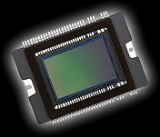
Let's look first at the physical size of CCD or CMOS sensor used to capture your photographs. Although there are slight variations, virtually all DSLR sensors fit into one of three size categories (starting with the largest); Full Frame, APS- C and Four-Thirds. Sensor size isn't as important as some people would have you think, but there are some key differences. The first is what is known as the 'crop factor'. As the diagram below shows, as the sensor gets smaller it captures a smaller area of the scene, resulting in a photograph that looks like it was taken at a longer focal length (1.5x or 1.6x longer for APS-C, 2x for Four-Thirds).
The crop factor isn't a major issue for most users, but it does have important consequences for some. If you're buying a digital SLR to replace a film model because you've got a kit
bag full of lenses you need to be aware that unless you buy a full frame model all your lenses will produce very different results on your new camera.
For telephoto shooters the result is quite a bonus, as all your lenses will effectively get even more powerful. On the other hand the crop factor means your wide-angle lenses will no longer offer anything like a 'wide' field of view. Fortunately there is a wide range of specially designed 'digital only' lenses for smaller sensor DSLRs.

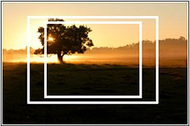

The three most common sensor sizes compared: full frame, APS-C and Four-thirds. Smaller sensors 'crop' the scene and make a lens appear to have a longer focal length.
For sports and wildlife shooters the smaller sensor has the effect of making their telephoto lenses and zooms even more powerful.

So which is right for you? Each has its own benefits and each has its limitations, and if you're building a DSLR system from scratch you needn't get too hung up on which is right for you.
The largest (and most expensive) DLSR format is full frame (so called because the sensor is the same size as a frame of 35mm film). DSLRs with full frame sensors have the biggest, brightest viewfinders and

because there's no crop factor are often chosen by photographers who are upgrading from a film SLR and already own expensive wide-angle lenses. The larger sensor also means that - all other things being equal - full frame cameras will produce the best results in very low light and at higher sensitivities. On the downside, full frame cameras are big and expensive, and there is only a handful of models to choose from. You also lose the focal length 'boost' offered by smaller sensor cameras when shooting with telephotos.

The larger the sensor the easier it is to get very shallow depth of field effects. The flip side of this is that it can be harder to get everything in focus when you do want to. Overall though, the larger sensors offer more control over depth of field for those that know how to use it.

APS-C is by far the most common format, used in virtually all Canon, Nikon, Pentax and Sony DLSR models. With a crop factor of 1.5x or 1.6x you need special digital lenses to get true wide-angle results, but these are readily available and are usually less expensive than their 'full frame' counterparts. The 'kit lens' supplied with most APS-C cameras is a good starting point, offering a versatile zoom range from wide- angle to short telephoto.
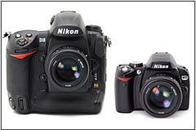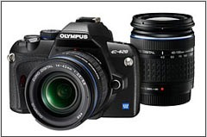

The difference in size and weight between a full frame professional level camera (Nikon D3, left) and a compact entry-level DSLR (Nikon D60, right) is considerable.
The Four Thirds system promises slightly more compact camera bodies and lenses. Four thirds is also the only DSLR system that uses the slightly squarer '4:3' format (as used on virtually all compact digital cameras).

Four Thirds is a new 'all digital' format developed by Olympus and currently used in Olympus and Panasonic DSLR models. Unlike the other systems on the market Four Thirds is not based on any existing film SLR system and uses a totally new lens mount, so all the lenses in the system are designed for digital, making the crop factor issues mentioned above less relevant. With the smallest sensor size Four Thirds offers slightly more compact camera bodies and lenses. Although the smaller sensor should in theory mean that these cameras produce noisier (grainier) results in low light and at higher sensitivities, for most purposes the difference isn't huge.

PHOTOGRAPHIC RESOURCE LIST
PHOTOGRAPHIC EQUIPMENT SUPPLIERS

Local Vendors – New Photo Equipment, Supplies & Services
Dodd Camera (www.doddcamera.com)
6475 East Galbraith Road, Cincinnati, OH 45236. Phone: (513) 791-3333

Local/Regional Vendors – Used Equipment & Repairs
Midwest Photo Exchange (www.mpex.com)
3313 North High St, Columbus, OH 43202. Phone: (614) 261-1264; Fax: (614) 261-1637
National Vendors – New and Used Equipment (Online)
Adorama (http://www.adorama.com). Phone: (800) 223-2500
B&H Photo, New York (www.bhphotovideo.com). Phone: (800) 606-6969 Ritz Camera (http://ritzcamera.com)
eBAY (https://www.ebay.com/b/Cameras-Photo/625/). KEH (http://keh.com/).
Roberts Imaging, Indianapolis (http://www.robertscamera.com). Phone (800) 726-5544

Camera Review and Forum Sites
Digital Photography Review (http://dpreview.com/) Image Resource (http://www.imaging-resource.com/)
Photography Review.com (http://www.photographyreview.com/) Photo.Net (http://photo.net)

Rev. 07-11-2021

